**ENSF-381**: **Full Stack Web Development Laboratory**

**Lab03**

**Section:**

**Group information:**

Armando Acosta (30209759)

Jessica San Juan (30003453)

**GitHub Link:**

[**https://github.com/jessicasanjuan/ENSF381-GROUP17-LAB3.git**](https://github.com/jessicasanjuan/ENSF381-GROUP17-LAB3.git)

**Exercise 1 Output:**

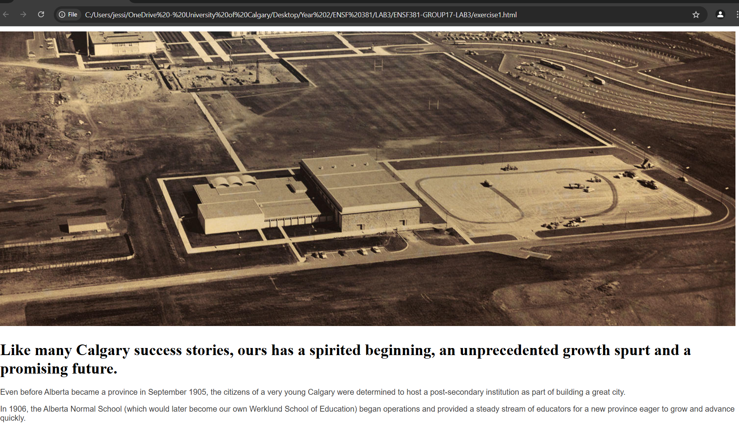

**Exercise 2 Output:** 

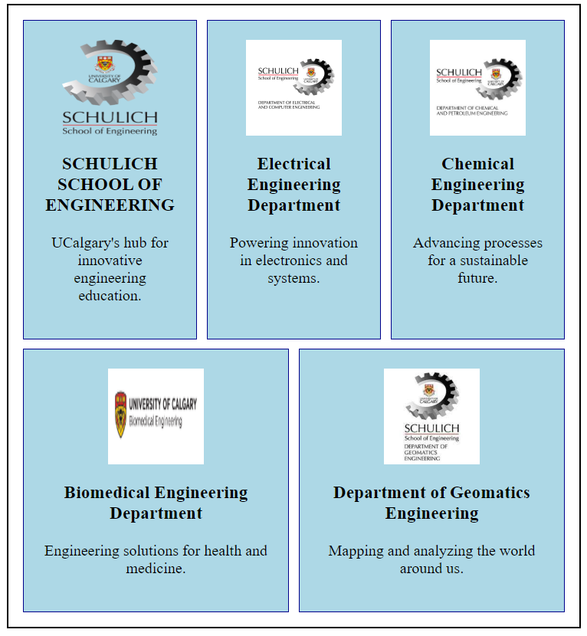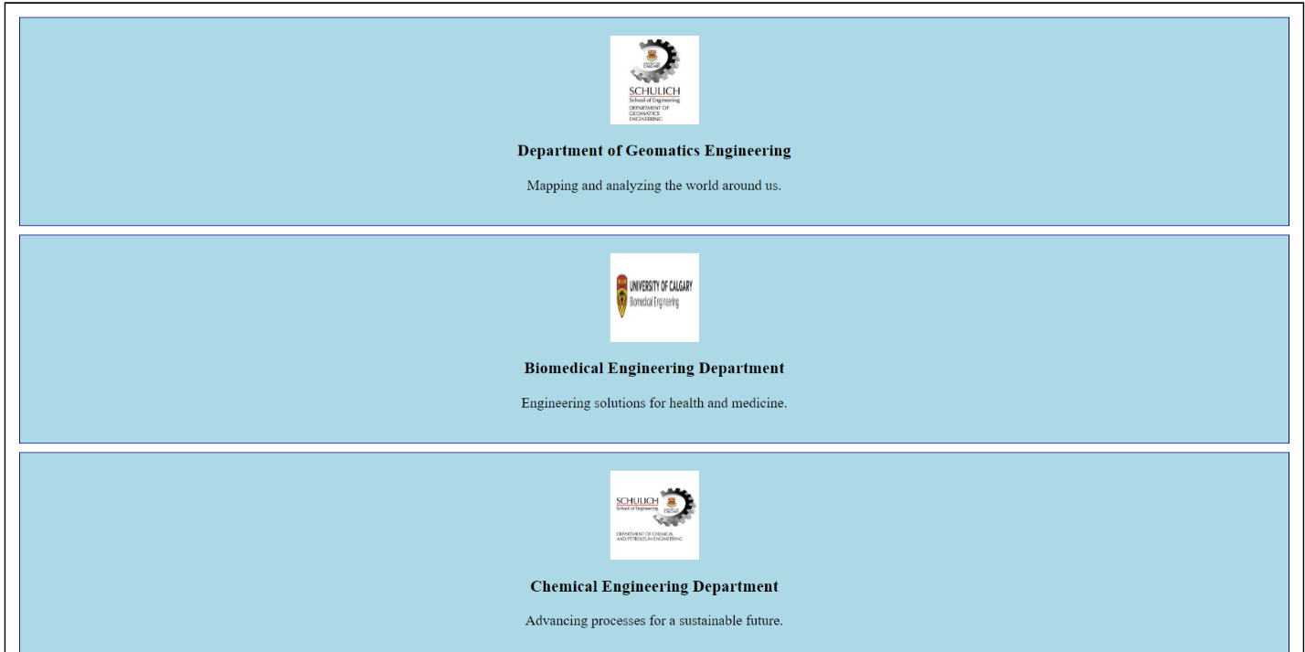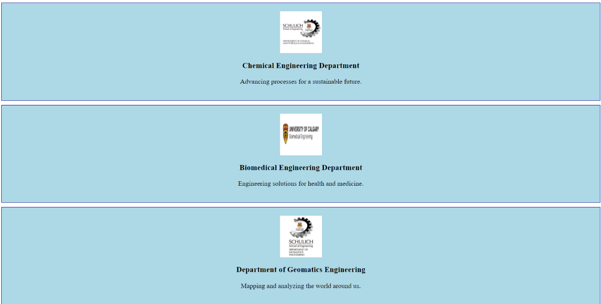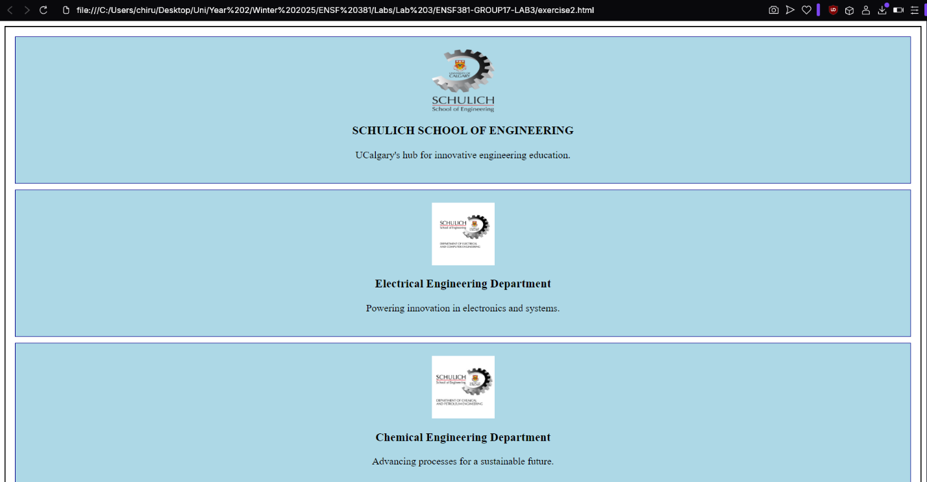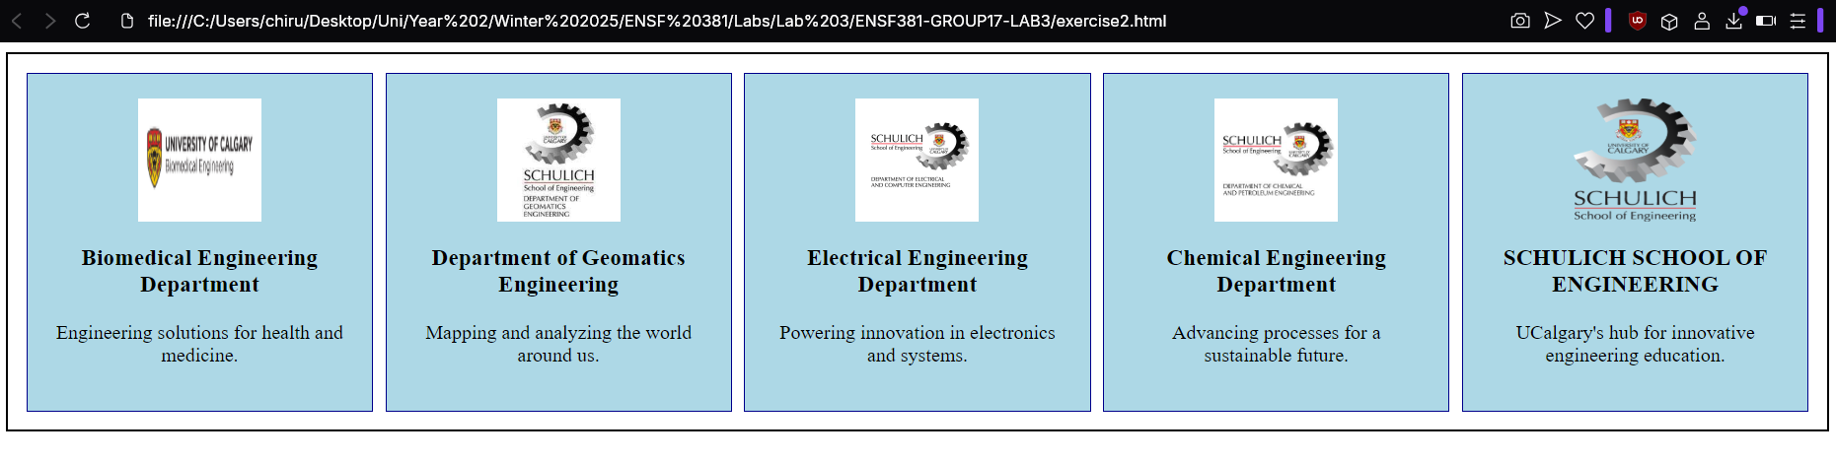

**Exercise 3 Output:**

